Smart Blind Stick
Technical documentation: obstacle and ground detection with SOS SMS and GPS location
Platform: Arduino Nano | Modules: SIMCom A7670C (GSM) and NEO-6M (GPS) | Sensors: 2 x HC-SR04 and soil moisture
Prepared by JustDoElectronics

1. Overview
The Smart Blind Stick is a walking aid for visually impaired users. Two ultrasonic sensors detect obstacles in front and behind. A soil moisture sensor detects wet ground. A push button sends an SOS SMS with the user's GPS location to two contacts. Each alert has its own buzzer pattern so the user can tell the events apart by sound.

2. Features and Alerts
Event | Sensor | Buzzer pattern | Meaning
Obstacle ahead (under 120 cm) | Front HC-SR04 (A1 / A0) | Fast beeps that speed up as the obstacle gets closer | Something in front. Slow down or stop.
Obstacle behind (under 80 cm) | Rear HC-SR04 (A2 / A3) | Double beep then a pause | Something close behind.
Wet ground | Soil moisture (A4) | Three short beeps then a pause | Water or wet ground on the path.
SOS pressed | Push button (D8) | Three long beeps | SOS SMS with location is being sent.
Startup | Not applicable | Two short beeps | Stick is ready.

Alerts are checked in priority order. A front obstacle is checked first then wet ground then a rear obstacle. Only one pattern plays at a time so the most urgent warning is always the one heard.

3. Components
- Arduino Nano (ATmega328P board running at 5 V)
- 2 x HC-SR04 ultrasonic distance sensors (front and rear)
- Soil moisture sensor with analog output
- NEO-6M GPS module with antenna
- SIMCom A7670C GSM/LTE module with antenna
- Push button (SOS)
- Buzzer (active or passive)
- 5 V 2 A supply for the A7670C that is separate from the Nano
- Active SIM card with an SMS plan and no PIN lock
- 1 kOhm and 2 kOhm resistors for a level divider. Also jumper wires and a breadboard or perfboard.

4. Pin Map and Wiring
The wiring diagram shows every connection. The table lists each pin used by the sketch.
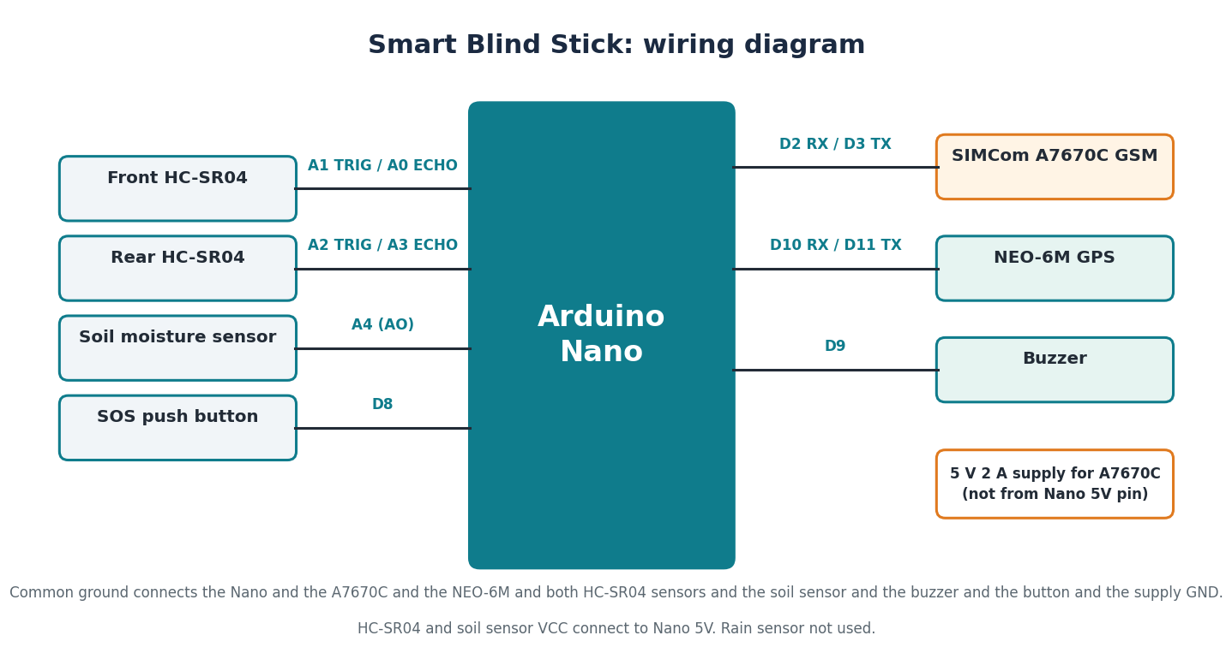
Device | Device pin | Nano pin | Note
Front HC-SR04 | VCC | 5V | Power from Nano
Front HC-SR04 | TRIG | A1 | Trigger output
Front HC-SR04 | ECHO | A0 | Echo input
Front HC-SR04 | GND | GND | Common ground
Rear HC-SR04 | VCC | 5V | Power from Nano
Rear HC-SR04 | TRIG | A2 | Trigger output
Rear HC-SR04 | ECHO | A3 | Echo input
Rear HC-SR04 | GND | GND | Common ground
Soil moisture sensor | VCC / AO / GND | 5V / A4 / GND | Low analog value means wet ground
SOS push button | Leg 1 / Leg 2 | D8 / GND | Uses INPUT_PULLUP so no external resistor is needed
Buzzer | + / - | D9 / GND | Works with active or passive buzzer
SIMCom A7670C | TXD | D2 (Nano RX) | Module transmits to Nano
SIMCom A7670C | RXD | D3 (Nano TX) through 1k and 2k | Divider drops 5 V to about 3.3 V
SIMCom A7670C | VCC / GND | External 5 V 2 A supply / GND | Do not power from the Nano 5V pin
NEO-6M GPS | VCC / GND | 5V / GND | Breakout board has a regulator
NEO-6M GPS | TXD | D10 (Nano RX) | NMEA data at 9600 baud
NEO-6M GPS | RXD | D11 (Nano TX) | Optional and not used by the sketch

Common ground: the Nano and the A7670C and the NEO-6M and both HC-SR04 sensors and the soil sensor and the buzzer and the supply must all share one ground connection.
Warning: never power the A7670C from the Nano 5 V pin. The module draws current spikes up to 2 A during transmission and will reset the board.
The rain sensor is not used in this build.

5. Working Principle

5.1 Sensor loop
Every 80 ms the sketch reads both HC-SR04 sensors and the soil sensor. Distance is measured by sending a 10 microsecond pulse on TRIG and timing the echo on ECHO. A value of 999 means nothing is in range.

5.2 Alert selection
The sketch chooses one alert per loop by priority. A front obstacle is checked first. The buzzer pattern runs without blocking the loop so the sensors keep updating while it plays. For a front obstacle the beep speed follows the distance. An obstacle at 15 cm gives 120 ms between beeps and an obstacle at 120 cm gives 900 ms between beeps.

5.3 SOS sequence
- The SOS button on D8 is read with a 50 ms debounce. One press starts the sequence.
- The buzzer is silenced and three long beeps confirm that SOS was received.
- The sketch waits up to 15 seconds for a fresh GPS fix that is less than 10 seconds old.
- The message is built as SOS! Blind user needs help. Location followed by a Google Maps link.
- An SMS is sent to each contact using AT+CMGS. The sketch waits for the greater-than prompt. It then sends the text and Ctrl+Z.
- The result (sent or failed) is printed on the Serial Monitor.
If no fix is available within 15 seconds the SMS still goes out. The message then states that the GPS fix is not available.

6. Setup
- Insert an active SIM with a data and SMS plan. Turn off the PIN lock.
- In the Arduino IDE install the TinyGPSPlus library from Library Manager. SoftwareSerial is built in.
- Open smart_blind_stick.ino and set CONTACTS[] to two phone numbers with the country code. Example: +919876543210.
- Set the A7670C to 9600 baud once. Its factory default is usually 115200 and SoftwareSerial on a Nano cannot run that reliably. Connect the module to a USB to TTL adapter. Send AT+IPR=9600 and save. Check your module datasheet for the exact procedure.
- Select Board: Arduino Nano. Choose the processor as ATmega328P or Old Bootloader for many clones. Select the port and upload.
- Open Serial Monitor at 9600 baud. Wait for GSM READY. If the module does not respond check power and wiring before continuing.
- Take the stick outdoors and wait 1 to 5 minutes for the first GPS fix.

7. Calibration
The soil sensor gives a different analog value when dry and when wet. The value varies between boards. Calibrate before relying on the wet ground alert.
- Read the soil value in Serial Monitor. Add a temporary Serial print of soilVal inside readSensors if needed.
- Note the value when the sensor is dry (in air) and when it is wet (in a damp cloth or water).
- Set SOIL_WET_BELOW to a value between the dry and wet readings. Choose a value closer to the wet reading to avoid false alarms.
- Test outdoors. Confirm that dry ground produces no alert. Remove the temporary print when done.

8. Code Walkthrough
Function | Purpose
setup() | Starts the serial ports and pin modes. Plays startup beeps. Initialises the GSM module.
loop() | Polls the GPS. Reads sensors every 80 ms. Selects and plays the alert. Checks the SOS button.
readDistance() | Triggers an HC-SR04 and converts the echo time to centimetres
readSensors() | Reads the front and rear distances and the soil sensor
decideAlert() | Applies the alert priority and sets the buzzer pattern
setPattern() and runBuzzer() | Start a new pattern and play it without blocking the loop
wasPressed() | Debounced edge detection for the SOS button
sendSOS() | Runs the SOS sequence. It confirms with beeps and waits for GPS. It sends the SMS to each contact.
buildSOS() and hasFreshFix() | Build the message text and check the GPS fix age
gsmListen() and gpsListen() | Switches the single SoftwareSerial listener between the GSM on D2 and D3 and the GPS on D10 and D11.
initGSM() and isRegistered() | AT handshake then text mode then network registration check for 2G/3G and LTE
sendSMS() | Sends one SMS with AT+CMGS and waits for the prompt and confirmation

SoftwareSerial can listen on only one port at a time. The sketch calls gsmListen() before any GSM command and gpsListen() inside pollGPS() so each module gets the port it needs.

9. Testing Checklist
- Startup beeps are heard and the Serial Monitor shows GSM READY.
- Moving a hand toward the front sensor makes the beeps faster.
- An obstacle behind the stick gives the double beep.
- A wet cloth on the soil sensor gives the triple beep.
- Pressing the SOS button sends an SMS to both contacts and the map link opens the correct place.
- The stick still works after a power cycle.
- Run the SOS test with a helper present before real use.

10. Troubleshooting
Symptom | Likely cause | Fix
SOS sent without location | No GPS fix yet | Go outdoors and wait 1 to 5 minutes. Check the D10 wiring.
GSM NOT READY at boot | Weak supply or no SIM or no network | Use a 5 V 2 A supply and check the SIM and signal
SMS fails with no prompt | Baud mismatch or not registered | Set the module to 9600 baud with AT+IPR=9600
Buzzer always sounds | Soil threshold too sensitive | Recalibrate SOIL_WET_BELOW
Front distance always 999 | TRIG and ECHO swapped or loose | Check A1 (TRIG) and A0 (ECHO). Sensor VCC goes to 5V.
SOS button does nothing | Wrong wiring or button not on D8 | Check that D8 goes to GND through the button. The sketch expects a press to ground.
Nano resets during SMS | Supply dips during transmit | Use a separate 5 V 2 A supply for the A7670C and add 1000 uF across its VCC and GND
Readings jump around | Noisy power or loose wires | Shorten the wires and add 100 uF on the sensor VCC

11. Limitations and Safety
- The stick is an aid. It does not replace a white cane or guide dog. The user must still watch for hazards.
- Ultrasonic sensors can miss soft and angled objects. Very thin items such as wires and glass can also be missed.
- The SOS SMS needs mobile network coverage. It cannot send where there is no signal.
- GPS needs an open view of the sky. Indoors and in dense areas the location may be missing or delayed.
- Confirm that your SIM network supports SMS on the A7670C before relying on it.
- The SOS button sends SMS only. Adding an automatic call is a code change.
- This is a prototype. Test it thoroughly before use and do not rely on it as the only emergency tool.

12. Assumptions
This document makes the following assumptions. Change the code or wiring if any of them is different in your build.
- The rear HC-SR04 faces backward and detects obstacles behind the user.
- The GSM module is wired to D2 (Nano RX from the module TXD) and D3 (Nano TX to the module RXD).
- The GPS module is wired to D10 (Nano RX from TXD) and D11 (Nano TX to RXD). D11 is not used.
- The rain sensor is not connected and is not used by the sketch.
- The A7670C is used for SMS only. Voice calling is not part of this build.
- SOS goes to two contacts. The sketch can be changed to use more.

